1/137--------------------------------007.

There are theories about how spymaster Ian Fleming assigned code number ‘007’ to James Bond and what its true origin was meant to signify. It denoted Bond’s ‘license to kill’ as an intelligence officer of British MI6 Secret Intelligence Service. Some Fleming enthusiasts claim it was 3-digit series from the telephone number of Fleming’s first literary agent, others claim it was inspired by the 007 train locomotive in Rudyard Kipling story in 1897 or by the daunting achievement of British naval intelligence breaking the German diplomatic code during World War I. The most telling explanation of its origination is that it comes from the realm of physics and represents the decimal expression of the fine structure constant and/or coupling constant: 0.0072973525693, or alpha. Named by physicist Arnold Sommerfeld in 1916, who quantified the electromagnetic interaction between elementary charged particles. Sommerfeld originally measured the gap in the fine structure of the spectral lines of the hydrogen atom. He found that each spectral line was a binary system of two finely separated parallel lines, extremely closely spaced—the magnitude was always 1/137 or a multiple power of it. His calculations incorporating the new Einstein’s Relativity Theory as well as accounting for the slight separation caused by the interaction of their electromagnetic fields spinning in opposite directions. Sommerfield’s original physical interpretation also found the fine-structure constant to be the ratio of the speed of an electron that occupied the first orbital shell of the Bohr’s model of the hydrogen atom to c, the speed of light in a vacuum.
Spectroscopy reveals the energy levels of atomic nuclei and unlike physical systems in Newtonian classical states which can exist as a continuum, quantum mechanics permits only a discrete although infinite number of energized states. When the atomic nucleus is hit with radiation of a particular energy, it is absorbed and released and form spectral lines that indicate the energy levels of radiation emitted by the atom as it rebounds back to equilibrium. Each element has its own spectrum of atomic energy levels and the irregularly spaced array of spectral lines act as identifying, unique fingerprints. These occur within the visible range but more often at the higher radiation in X-rays. The atom is effectively an infinite but countable number of tuning forks that are set in motion by bombarding radiation; whereas an individual turning fork when its tines are struck resonates at a single, innate frequency that one hears as pitch, the vibrating frequencies of the atomic ensemble materialize as spectral lines. These spectral lines indicate the energy levels of radiation emitted as it rebounds back to equilibrium. Atomic spectroscopy requires the excitation of the circulating electrons orbiting the nucleus. The fine-structure constant, alpha, has several physical interpretations but is predominantly a ratio of energies, or ratios of bigger things to smaller things integral to modern physics, chemistry and biology that tend to be powers of its measured value. Alpha manifests itself often if unexpectedly in formulas governing light and matter. In architecture, art, and biology there is the Golden Ratio [1.6180339887] and alpha parallels that numbers importance and relevance in a wide range of circumstances. Alpha was not seen as significant until Paul Dirac’s linear relativistic wave equation in 1928, which produced the exact fine structure formula. In quantum electrodynamics, alpha is directly related to the coupling constant determining the force of the interaction between electrons and photons. It describes the ratio of the energy required to overcome the repulsive force between two electrons a set distance d apart to a single photon with a wavelength of lambda = 2 X ∏. Quantum electrodynamic theory does not predict its value so thus it is measured experimentally. Physicists know that precise measurement of alpha because its value appears everywhere will allow them insight into the interrelationships between elementary particles and to test the set of equations that define the Standard Model of particle physics.
It was physicist Max Planck and his work with electromagnetism that formed the basis of what would become quantum theory. He theorized that some absolute minimum of energy was carried by every electromagnetic wave, no matter how short its wavelength and for longer wavelengths would have to be a discrete, multiple [s] of that baseline wavelength. An individual atom vibrating at a particular frequency could only emit energy that were whole number multiples of that minimum which he approximated at 6.6 X 10 minus 34 joule-seconds, represented by symbol h, and now known as Planck’s constant. The atom could emit nothing less than h times its wave frequency [v[. He called the energy of emitted or absorbed quanta, and they were never in fractional multiples.
Denoted by the Greek letter alpha, the fine-structure constant has been acclaimed as one of the great mysteries in the physical sciences by renown physicists Richard Feynman and Wolfgang Pauli, originators of Quantum Electrodynamics [QED]. Paul Dirac said that its origin, and what lay behind the constant, was one of the greatest unsolved problems of physics. QED theory is astoundingly proficient in analyzing electromagnetism and the fine structure constant is ubiquitous within QED where its significance has broadened from atomic spectroscopy to a general coupling constant determining the strength of the interaction between electrons and photons. In our Universe, everything comes down to gravity or the force of electromagnetism and the alpha constant is important in that it also characterizes the electromagnetism between electrons and protons in physical matter. It is a ‘constant’ in physics that fluctuates very slightly because the effective electrical charge of the electron changes minutely when one varies the scale of the experiment. It approximates 1/137 at low-energy levels but in large-particles accelerators its value increases by 7 % to 1/128.
There are certain numbers in physics that are profound such as the speed of light, Planck’s constant, the Newtonian gravitational constant, the Faraday constant but alpha is an important component of the equations that explain the Standard Model that deals with the weak and strong nuclear forces, and electromagnetism. In other words, it helps set the relationships and ratios that manifest themselves in all the basic forces of nature except gravity. It is a pure number that comes to us with no understanding. Unlike the other constants, alpha is dimensionless but has recently been measured by a team of Parisian researchers as 1/137.035999206 or expressed decimally as 0.0072973525693. In its derivation, all units cancel each other out. Because it is so small, the force of electromagnetism is weak enabling charged particles to form chemical bonds when electrons that circumnavigate at distance from the pull of the nucleus interact with the electrons of other elements. It is debatable that if that alpha was less than 1/138 than carbon—essential for the organic molecules of life---could not be formed in stars. It also describes the relationship between the fundamental physical constants where e is the elementary charge, h is the Planck constant, ⴌ is the reduced Planck constant, c is the speed of light, and eo is the electric constant.
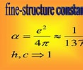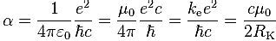
***
Prime numbers are positive whole numbers greater than one which only have itself and the number one as factors. By convention, the reciprocal of the fine-structure constant is often denoted. It is the reciprocal of the 33rd prime number, 137--- which with 139 comprises the eleventh twin prime. Usually 1, 2, 3 are not counted as twins, since one [1] is despite meeting the definition of a prime is not included by convention and two [2] is the only even prime, also this triad is only separated by one and twins differ by two spaces---- considered the minimum between any consecutive prime numbers. Twin primes on the number line as it reaches toward infinity are always separated by two, no matter how large the number or how far up the number line. Is there a parallel to the 1/137-ish and its multiples that separate atomic spectral lines?
**
The number 137 can be derived from simple geometric structures formed by multiples of eight raised to the powers of 0, 1, 2, 3 and 4. The precise figure for alpha derived from geometric means is 0.007297351 with a reciprocal of alpha of 137.036035407.
Geometrically, alpha is represented approximatelyly by the Fine Structure Formula :
- ⎷ 137+0.875 or 8˚˚˚˚˚˚ + 8¹+8²+4 X [8³]+ 4 X [8⁴]

Where does 1/137-ish come from, why is it so frequently encountered and does it as a prime number have a bearing on its significance? Why has it become the obsession of savants in physics? It describes relationships among the constants and acts like it was chosen at random at the very beginning of our Universe and forms a connection with the other important numbers in physics. Was it just arbitrarily set and everything else is proportionally related to it? Cosmologists who promote a multiverse where our own Universe where we live is just one of many worlds that think that every universe has its own similar bur special number; we just happen to have what we have, 1/137. Others see no importance to its prime number roots. Both scenarios are unlikely, improbable and from this author’s perspective farfetched. We have but one universe presently and if others have or will exist, they develop chronologically, not simultaneously. And in mathematics and physics, there exist an uncanny resemblance where on the average the orbital energy levels of electrons orbiting in shells around the complicated nuclei of the heavy elements in the Periodic Table and the most advanced unresolved question in mathematics today, the distribution of the zeta-zeros of the Riemann Hypothesis which lays at the core of what we know about the distribution of the infinity of prime numbers. There is a hidden, mathematical relationship between the numbers that describe the energy levels of the fundamental wave functions of a typical ‘heavy atomic nucleus like an isotope of erbium or uranium and the distribution of the nontrivial zeta-zeros on the magical critical line where the complex numbers whose real part is equal to one-half. The Reimann Hypothesis, if true by formal mathematical proof confirms a tight, precise estimation of the distribution of primes among the natural numbers. The primes on the number line appear farther apart as one approaches infinity but the nontrivial zeros become packed closer together as one climbs the critical strip. And the density of one set [primes or zeta-zeros] is roughly the reciprocal of the other arithmetic set. That all the nontrivial zeros must lie on the critical line is the prized resolution of the most important question unresolved in mathematics, the famous Riemann Hypothesis. Encoded in the Riemann Hypothesis is the precise detail of the accumulation and distribution of the prime numbers which are the basic ‘atomic’ building blocks of all the natural numbers but also to nature itself. The distribution of the nontrivial zeta zeros might parallel the eigenvalues found in the matrices constructed by physicists to calculate the energy levels in the heaviest atoms in the real world. Eigenvalues in physics are defined as the scale magnitude a matrix function transforms, contracts, or expands, a defined state of space. The nucleus of a heavy atom is a complicated miasma of interactions of neutrons and protons held together by the strong force which counteracts the electrical repulsion of the positively and similarly charged protons. In electromagnetism like charges repel, opposite charges attract. The tightly wound nucleus is also influenced by the surrounding negatively charged electrons. An exact knowledge of position and momentum is replaced by a wave function which mathematically estimates the probability of a particular configuration at any one time and location. There exists at least an analogous relationship between the energy levels displayed in heavy atomic nuclei and the nonrandom, fairly-uniform spacing of the Reimann’s zeta-zeros.
It is not uncommon to hear physicists brag about the “unreasonable effectiveness” of mathematics to describe the mechanics of the physical world. If numbers represent our efforts to organize the Universe, physicists use the mathematics of matrices to analyze the transformation within the atom. In a simple matrix, one number is assigned to a square, and the squares assembled in rectangular grid like a chessboard. A matrix represents a transfiguration of space, either physical or abstract. A matrix has a specific set or collection of eigenvectors which is the state of space transformed by a matrix. The amount by which a matrix increases or decreases an eigenvector is the eigenvalue. Each eigenvector has a corresponding eigenvalue which quantifies its transfiguration within the state defined within the matrices. If the state is hue, then the scale is the intensifying or dulling of the selected color frame. The Dyson-Montgomery-Odlyzko conjecture states that the spacing distribution for the nontrivial zeros correlates directly with the spacing distribution for the eigenvalues of a randomly chosen Hermitian matrix. The latter is a matrix with complex numbers in which the entry in a given row has the same real part , but an opposite sign imaginary part so that the entries across the diagonal must be only real numbers.
The heavy, complex atoms are too complicated to understand, and their workings cannot be ascertained like that of a simple, hydrogen atom. Statistical analysis led us to try to comprehend them by their group or ensemble behavior, the range or distribution of possible behaviors that occur over many possible nuclear situations. It is fortuitous that if one looks at what is occurring on average, it will approximate well with what is observed as happening individually.
***
Reimann used a sophisticated function that was known from the time of Euler and modified by Dirichlet called the zeta function. It deals with an infinite sum of numbers and it was a revelation what a powerful this tool would become in exploring the distribution of prime numbers.
Zeta Function & Euler’s Prime Product Formula: 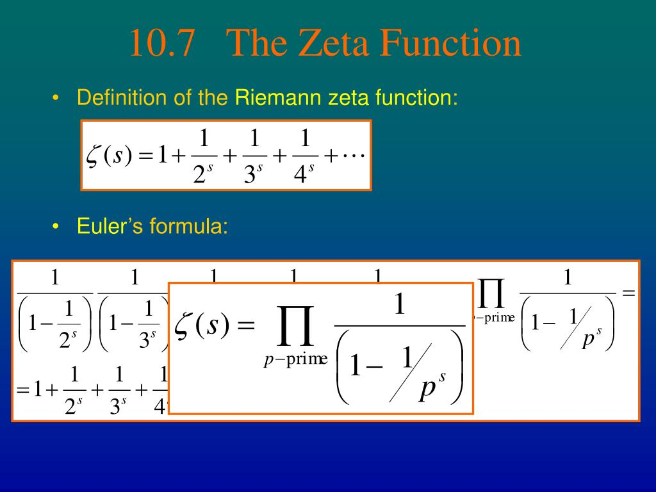
The infinite sum 1+1/2+1/3+1/4…is known as the harmonic series because its origin comes from music. It was the Greek mathematician Pythagoras who filled an urn with water and struck it with a hammer to produce notes. Each time he added water in random amounts he obtained musical notes that were dissonant to the original except when he measured the urn to be ¼, ⅓ , ½ filled did he hear notes that were in harmony with the original note produced when the urn was full. Euler, when he fed the zeta function with x = 1 saw the output spiral off to infinity. If Euler fed in x as > 1 the output would home in on a finite number, the square of ∏ multiplied by the reciprocal of six. No one had predicted that the simple harmonic sum would be correlated with the number Pi [∏]. He found something unsettling about the zeta-function in that it behaved well only for numbers larger than 1. The Greeks had discovered that every composite number can be obtained by multiplying prime numbers together, and Euler realized that he could rewrite the zeta-function by using prime numbers. Instead of writing the harmonic series as an infinite sum of all the fractions, he took single fractions made from primes, like 1/3, 1/5, 1/7, 1/11, 1/13…, and just multiplied them together. He expressed what the Greek’s had discovered two thousand years ago in a 19th century mathematical perspective to rediscover the proof that there were an infinite number of primes. For Reimann, the zeta-function represented an opportunity to input the imaginary numbers that had intrigued him from studying the work of Cauchy. Imaginary numbers are complex numbers that have a real part equal to zero. They are expressed as A + I X B, where A and B are real numbers and the symbol, i, denotes the square root of negative one. B is the imaginary part of the complex number A +i B. When Reimann did so, he discovered an ‘Alice in Wonderland’ new world that provided a vista to explain the world of prime numbers including why the Prime Number Conjecture formulated by Gauss was true. He saw that Gauss’s hunch that the percentage difference between his logarithmic integral and the actual number of primes would diminish as one counted higher. The zeta-function was a looking glass in which the primes transformed. He had a strong geometric intuition and to Reimann it was the geometry of the graph that was significant when he was feeding imaginary numbers into the zeta-function. To graph it completely , Reimann had to work in four dimension and we typically see and comprehend things in only three spatial dimensions. He developed a graphing technique that used two dimensions to keep track of the coordinates of the imaginary numbers fed into the zeta-function. The third and fourth could then be used to record the two coordinates describing the imaginary output of by the zeta-function. The north-south axis keeps track of how we progress in an imaginary direction and the east-west axis charts the real numbers. If we lay this graph flat on a tabletop, it is the physical shadows that compose the landscape above the map that we want to investigate. The shadow of the zeta-function will turn into a physical object with hill and troughs that we can explore to better comprehend Reimann ideas and his intuitive approach. The height above each imaginary number on the map records the result of feeding that number into the zeta-function. What does Riemann’s particular three-dimensional shadow of the zeta-function look like? As Reimann explored his landscape he saw several prominent features. Standing in the landscape and looking eastward he saw a smooth plane plateauing exactly one unit above sea level. As he looked west, he saw peaks of hills of various heights rising upwards, that were all located through the perpendicular line that intersected the east-west axis of real numbers at number one. At the exact intersection at number one on both the horizontal and vertical axis, the peak was insurmountably high. This corresponded to Euler feeding the number one into the zeta-function and the output zooming to infinity. Reimann discovered to his chagrin that the zeta-function could not build a landscape out to the west of this mountain range; he experienced the same obstacle that Euler found when he fed into the zeta-function any ordinary number less than one. The marvel of Reimann’s work is that he found another equation, a formula to construct the missing landscape to the west and the completed map composed of imaginary numbers. The imaginary landscape he discovered to the west had an inflexible, rigid, geometric make-up. There was only one way it could be expanded and it was what happened eastward of the mountain range that governed what unfolded upward as one headed westward. Another weird but astounding feature was that at the points where the altitude of the landscape plummeted to zero were like the X ‘marks the spot’ on a pirate’s treasure map. The zeros where the landscape bottomed out, when analyzed, could be utilized to reconstruct every feature of the whole landscape. It worked as if someone walking along a shoreline beach could glean enough information from his beachfront stroll to see just how to make an accurate cartographic map of the whole interior continent. The zeta zeros acted like the light spectrum emitted by an element or chemical compound. It was akin to astronomers deducing the chemical composition of a far-away star by analyzing the spectroscopy of the light emitted.
It had been Euler’s formula for the zeta-function by using Euler’s product that had created Reimann’s imaginary shadow landscape. If prime numbers and the zeta-zeros constructed the same cartographic features, then there existed a relationship between them. The brilliance of Reimann was how he discovered that the primes and zeros were two sides of the same equation. Gauss estimated through his Prime Number Theorem the number of primes up to any number N but Riemann produced a new function that was an improvement although it was still producing errors. Riemann realized that the points where the landscape was zero could also eliminate the error and provide an exact count of the primes. Euler had uncovered that an imaginary number fed into an exponential function produced a Fourier sine wave and Riemann saw how each of these zero points produced its own undulating sine wave. Reimann added the height of each special sine wave to his R [N] function that already gave a better estimate than that of Gauss, he could count the absolute number of primes up to number N. The equation expressing the exact count of primes equated to ‘primes = zeros = waves.’ The north-south coordinate of each zero controlled the frequency of the sine wave and determined the pitch acting like a tuning fork, producing clear notes with no overtone harmonics. The zeta-zero coordinates of the east-west axis controlled the fluctuations of an undulating graph or how loud a note would play. The farther eastward, the higher the amplitude of the note produced by the sine wave would be and the greater its volume. The zeros that stretched out to the west directly on the x-axis had no height, nor pitch and since they provided little insight, mathematicians would come to label them the trivial zeros. How Riemann calculated the first nontrivial zeros was an enigma for many years but his first zero had the coordinates [½, 14.134725…, the next zero was at ½ 21.022 and the third was designated with ½, 25.022040---all the zeta zeros were lining up in regiment at east--- ½ step---and were not scattered at random. He already understood that the east-west axis represented a line of symmetry in that anything in the north would be reflected similarly to its counterpoint in the south. The ley line running north-south at ½ more importantly was a line of symmetry and he wrote that it was his speculation that all the zeta-zeros lay on this magical, critical line within the critical strip. Again, this conjecture is the Reimann hypothesis. If true, it means that the corresponding sine waves at each zero were in perfect balance, none more dominant than another in controlling the count of the primes. None producing notes louder in volume than any other, and furthermore the more eastward a sine wave the louder the note and the more the error in Gauss’s original projection of the number of primes below number N. If Reimann’s conjecture was true, it meant that Gauss’s initial guess was accurate and gained greater precision the more primes one counted. The zeta-zeros also occur closer as we move up the critical line. The fall of the zeta-zeros is much more evenly distributed than what be expected randomly, a feature that is referred to as repulsion. They behave as though they were like-charged atomic particles so that the overall net effect is nearly universal spacing. If one scrutinizes the energy levels in the nucleus of erbium, element 68 in the Periodic Table, when it is bombarded by low-energy neutrons in experimentation, there is a strong resemblance to many segments of the zeta-zeros on Riemann’s ley line. Physicists now believe atoms behave less like a planetary system and more like a drum and the vibrations one creates when you bang it are built from certain wave patterns each with its own frequency. Each different atom in the Periodic Table has its own distinctive set of frequencies exploited by spectroscopists to identify the elements or compounds present. The physics of an atom differs from a percussive drum in that to solve the equations that explain the behavior of atoms, one is obliged to use imaginary numbers. Physics and mathematics often overlap, ranging over similar territory but no one predicted that Riemann’s number theory and quantum physics would be interconnected. There is a realistic chance the zeta zeros lining up in a straight line at ½ can be explained using the equations of quantum physics. A zero off the line may be like an imaginary energy level within an atom that is not permitted by quantum mechanics. Occam’s razor states that ‘given two explanations of an event, chose the simpler’. It may boil down to just an analysis of their innate existentialism for both physical particles and the zeta-zeros. The latter can only exist at the absolute bottom of the Riemann landscape and the former as exemplified perhaps by an excited electron releasing a photon after irradiation to equilibrate to its resting energy state---just is an ephemeral whisp that comes back into its own only when the transfiguration is completed. Phenomenal feats of computation have found the zeta-zeros on the ley line 10 to the power 20 steps north and not only do they remained fixed on the ley line but the spacings between the zeta-zeros, the gaps, and their statistical analysis, are connected to some complicated but powerful mathematical drum that parallels the similarities of spacing between the energy levels of heavy atoms like uranium. There are data bases now online where the precise coordinates of the first 103, 800, 788, 359 zeros of the zeta function are listed, all on the ½ Reimann ley line. Brute computational force will remain inconclusive as a determinate proof of the Reimann Hypothesis.
In mathematics, one pursues not only the truth but a formal rigorously constructed proof that it is true. The formal proof of Riemann’s Hypothesis has eluded us for 165 years now. And more pertinent to this writing, the fine-structure constant, 1/137—the reciprocal of 137-- despite no formal proof or clear evidence, is also deeply integrated with the connection of prime numbers and quantum physics. One is the building blocks of numbers while its physical counterpart is the building blocks of matter.
R. Anthony Saritelli August 11, 2023.
Dedicated to Georg Friedrich Bernhard Riemann who died from tuberculosis at age 39 years near Lago Selesca, Italy during the Summer, 1866---- seven years after publishing his famous paper on the primes in 1859.
References:
O’Dowd, M. PBS-Spacetime: Season 8: Episode: Why Is 1/137 One of the Greatest Unsolved Mysteries in Physics?
Willett, The Library of Physics: Understanding the Photoelectric Effect & Line Spectra. The Rosen Publishing Group. New York. 2005.
Fine Structure Constant-Wikipedia
Scanlon, GW: The Origin & Geometry of the Fine-Structure Constant. North haven, Ct. 08/2023.
Nelson, B. Question 186: What Is The Significance of the Number 137 in Physics? PhysLink.com. Long Beach, CA 1995-2023.
Wolchover, N. Abstraction Blog: Physicists Nail Down the ‘Magic Number’ That Shapes the Universe. December 3, 2020.
Twin Primes-Wikipedia
Rockmore, D. Stalking The Riemann Hypothesis: The Quest to Find the Hidden Law of Prime Numbers. Vintage books-Random House. May 2006.
Du Sautoy, M The Music of the Primes: Searching To Solve The Greatest Mystery in Mathematics. Fourth Estate; Great Britain. 2003. United States. HarperCollins Publisher. 2003.

