The Inside Angle on Our Tilted World.

Cat’s eyes do not only see better than us in the dark, but they can manage direct sunlight and glare better. This is my thought from watching my Catapult’s morning ritual on cloudless days when the winter sun is rising. As I lay in my bed, he climbs his rug lined tower and stares outside at the Sun as it breaks the horizon. He is transfixed by the rising morning star and his steady gaze is so determined that I surmise that his feline eyes are better in dimming the growing light which soon forces me to avert my gaze. Often, he stands and stretches never stopping staring at the bright, yellow star emerging slowly above the horizon. His instinctual curiosity was infectious though, and it triggered my efforts to conjure up from my memories what I once knew about the Earth’s annual revolution around our Sun and our four seasons. I had forgotten all but the basics and I decided to embark on a quest to rediscover what long ago I learned from science class and go beyond where this one man had never gone before in understanding this aspect of astronomy. One giant leap for me was grasping that on each one annual revolution fluctuations are insignificant and imperceptible. The Earth does not shift its tilt back and forth as it revolves around the Sun or alternate its tilt orientation from one year to the next. Poorly designed illustrations and diagrams representing the seasonal changes are often misleading due to changing camera perspective giving snapshots of the Earth’s orbital movement and a lack of emphasis on the direction of travel---the Earth revolves counterclockwise around the Sun. As the Earth circles its star, it passes through its four seasons, but it remains practically locked in its tilt and its directional orientation on any one orbit. Changes do occur but only over the grandest scopes of passing time. Circling is not quite accurate because the Earth’s orbit is elliptical. If it were a true circle, the Earth would move at a constant speed as it revolves at an unchanging distance. If the Earth had no axial tilt [obliquity] from the orbital plane there would be just one season with only minor variations in climate.
Periapsis is the point where an orbiting object is closest to the body it is orbiting. Apoapsis is the point at which an orbiting object is farthest away from the body it is orbiting. When referring to objects revolving around the Sun, more descriptive terminology is perihelion and aphelion.
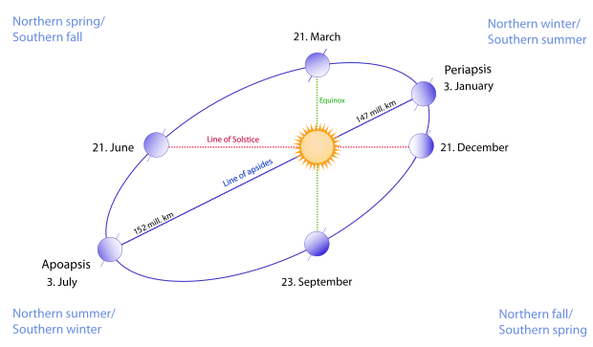
An Ellipse Is a Flattened Circle: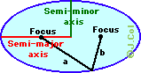
An ellipse is an oval where all the points in lie in a plane forming a perimeter that satisfies the equation where the lengths [a + b] equal twice the length of the semi-major axis. [A] is the distance from one focus to a point on the boundary of the ellipse and [B] is the distance from the other focus to the same point on the ellipse’s perimeter. An ellipse is an elongated oval with two foci symmetrically positioned toward the narrower ends. The Earth’s orbit has the Sun anchored at one focus and the other focus is empty. According to Johannes Kepler’s Second Law, the line connecting the Sun to our planet sweeps out equal areas in equal times. The motion is not symmetric, as our planet approaches the Sun it speeds up and it slows down as it progresses further away from it. Distances are measured from the center of celestial bodies. The orbits of the planets around the Sun do not retrace an identical ellipse every revolution but rather trace out one slightly different iteration, one after another, forming a flower-petal shape with repetition of orbits. The gravitational tidal forces of the Moon, the Sun, and the planets especially Jupiter pull on the equatorial bulge causing the Earth’s orbit to precess. This process is called perihelion precession or apsidal precession and causes a slow and gradual rotation of the Earth’s elliptical orbit around the Sun. It is a major cause of climate oscillation including inducing past ice ages and its period ranges from 19, 000 to 23,000 years. The orbital precession rate of the Earth exceeds that of the other bodies including the planets in our Solar System whose orbits are more circular and nearly stationary. Mercury’s predicted perihelion precession rate has historical significance. The smallest planet’s successive revolutionary orbits around the Sun derived from Newtonian physics deviated from the observed precessional turning rate of that planet’s orbit by a discrepancy of 43 seconds every century. It was Einstein’s General Theory of Relativity that accurately foretold this anomaly from classical mechanics and the provided observational evidence from astronomy that explained the quandary of Mercury’s orbit, was the first proof that supported its acceptance.
The Earth reaches its highest velocity at perihelion when it is at its shortest distance and moves slowest at aphelion when its distance is farthest.
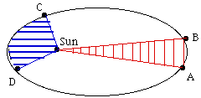

A Fortnight Shy of Aphelion & Perihelion:
Due to variations in the eccentricity of the Earth’s orbit, the dates the Earth reaches perihelion and aphelion are not immutable. The days can vary up to two days from one year to another. In 2022, the Earth was closest to the Sun on January 4th at 91, 165, 517 statute miles [5280 ft] and reaches aphelion on July 4th at 94, 509, 598 miles. At the June 21st solstice in 2022, the Earth is 87,868, 383 miles away, just 6, 641, 215 miles short of its maximum distance at aphelion. The June solstice is Day 172 whereas the aphelion on July 4th is day 185 on the 2022 calendar. Aphelion in Providence, Rhode Island, my location, occurs on Monday July 4th, 2022--at 3:10 AM EDT whereas the June solstice occurs on Tuesday June 21, 2022, at 5:13 AM EDT. An interval just 2 hours 3 minutes shy of a fortnight! In Providence, there will be 6 hours and 5 minutes more daylight that first day of summer than on the December solstice. In 180-days, the Earth travels 3, 344,081 miles until it reaches perihelion. At the December 21st solstice, the Earth is 91, 749,590 miles from the Sun, picking up speed as it approaches perihelion on January 4th. It averages 17,142 miles a day over the 14-day period. Due to variations in the eccentricity of the Earth’s orbit the annual perihelion day drift by one day every 58 years.
Eccentricity measures the ovalness of an ellipse and the Earth’s orbit is nearly circular at 0.0167. Only the elliptical orbits of the planets Venus and Neptune are more circular. Over the course of hundreds of thousands or years it varies from 0.0034 [more circular] to 0.058 [more oval] because of the gravitational interaction among the planets of our Solar System. In 1246 AD, the December Solstice was at perihelion and in 6430 AD perihelion will be on the March Equinox. The latter phenomenon will make the respective vernal and autumnal equinoxes for the northern and southern hemispheres---which always occur simultaneously---happen when the Earth is at its closest point to the Sun!
It is also paramount to realize that it is the elliptical shape of the orbit in conjunction with the tilt that causes the sun rays to strike the Earth perpendicular at different latitudes produces the seasons. The distance of the arc on Earth between the Tropics of Cancer and Capricorn is 3,274.4 statute miles and the Sun’s rays migrate steadily between these lines of demarcation; the light rays hit perpendicular [striking at 90 ˚] at the Equator on the March Equinox before migrating vertically to its most northernly point at the Tropic of Cancer on the June Solstice before halting, reversing, and striking he Equator again at the Autumnal Equinox, then transgressing to its most southernly latitude at the Tropic of Capricorn on the December Solstice. The Tropics of Cancer and Capricorn are situated 23.44 degrees N and S of the Equator. The annual solstices are one moment in date and time when the vertical movement north or south comes to an abrupt halt and the Sun appears to hold its highest or lowest declination in the sky. Solstice comes from the Latin, sol for Sun and sistere meaning ‘to stand still’. The December Solstice has the shortest period of daylight and the longest night of the year. The Sun is at its lowest elevation in the sky in the northern hemisphere. The June Solstice has the longest daylight period, the shortest night and the Sun reaches its highest elevation in the sky in the northern hemisphere. The opposites are true in the southern hemisphere. The Sun can only reach directly overhead [astronomical zenith] at positions between the two tropical lines marking the upper and lower limits of its apparent migration. At each tropical line it will be 90 degrees overhead only at the corresponding summer solstice; other locations between the tropical lines will have the Sun directly overhead on two days including the Equator which occur on the days when the Sun is overhead during the two equinoxes. The famous adage that the Sun rises in the east and sets in the west is only precisely accurate on the days of the March and September equinoxes when the hours of daylight and nightfall are equivalent. On the equinoxes, everywhere on Earth, the Sun will rise due east and set due west. On the June Solstice, the Sun rises considerably north of due east and it sets considerably north of due west. On the December Solstice, the Sun rises considerably south of due east and sets considerably south of due west.
The astronomical zenith when an object is perpendicular to an observer below:
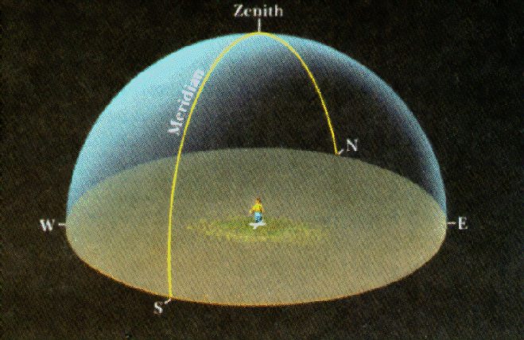
Illustrations of Sun Angles for Summer and Winter solstices and at the Vernal & Autumnal equinoxes on left. Depictions of Sun Angles in the Northern Hemisphere on right.
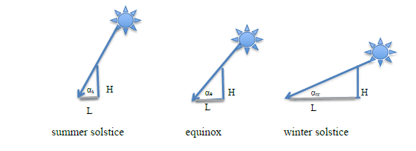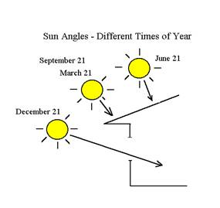

Axial Tilt:
If the poles of the Earth were not tilted, then we would experience only two seasons summer and winter as we approached perihelion and aphelion with temperature differences varying according to latitude with only pronounced differences in solar insolation at the far poles. The present tilt of the Earth from the perpendicular of the orbital plane is 23.44˚. It represents 26% of a clockwise turn from 90 ˚to 0˚ and this is relevant because the Earth is not a perfect sphere for it is flattened at its poles. The circumference of the circular arc that runs through the poles is 24, 859.82 miles, as such 41.7 miles shorter than the measured circumference at the Equator. The radius from the center of the planet to the poles is 3950 miles whereas the radius distance to the Equator is 3963 miles, the diameter from pole to pole is 27 miles shorter than the Equatorial diameter. The Earth is an oblate spheroid differing from a perfect sphere by one-third [⅓] of one percentage point. The flattening ratio is 1:298.257 making the tilt less pronounced as it extends out from the poles than it would be if it equaled the longer equatorial radius. If the polar radius were equivalent to the equatorial radius, the interval from the solstices to the perihelion and aphelion would be proportionately longer also.
The circumferences at the Tropics of Cancer and Capricorn are equivalent at 22, 847 miles. The latitudes of the tropics north and south of the Equator equate to the current obliquity from the orbital plane or tilt of 23.44 degrees. They are imaginary lines that adjust with the ever-so-slow, gradual altering in the degree of tilt of the axis of our planet. From the diagram below, one can see that the tilt angle is presently about half-way between it minimum and maximum values where one complete cycle ranges over 41, 000 years. It will reach 22.1 ˚ in 11, 800 AD and the interval from the solstices to perihelion and aphelion will shorten accordingly. It was back in 8700 BC when the tilt was 24.5 ˚and the intervals between the solstices to perihelion and aphelion were at its longest duration.

The range in degrees of the axial tilt cycles over 41,000 years. 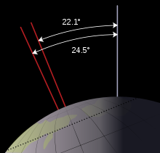

A Sun Rays Journey: Only 1347 ½ More Miles and Summer Becomes Winter

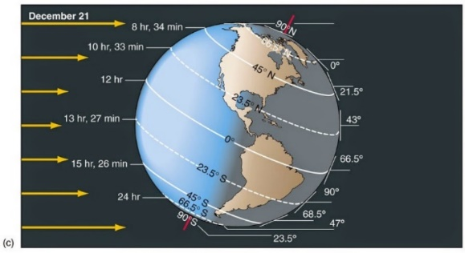
In the above diagram, it is the first day of summer in the Southern Hemisphere and the first day of winter in the Northern Hemisphere. At the Tropic of Capricorn where the sun rays hit perpendicular at 90˚, there are 15 hours and 26 minutes of daylight but at the Tropic of Cancer where the angle of solar radiation is oblique, there exists only 10 hours and 33 minutes of daylight. It is important to compare the angle of incidence and amount of solar radiation along the same meridian. The time up-and-down the same line of longitude is the same; if it is noon at the Prime Meridian in London, England it is also noon in Togo, West Africa---and everywhere else at longitude 0˚ East. The distance that some sun rays travel through Outer Space and the Earth’s atmosphere after the first rays strike flush on the Tropic of Capricorn to the Tropic of Cancer at a similar longitude is astoundingly small, 1347.49 statute miles by my back of an envelope calculations; while the distance from the center of the Sun to the center of the Earth is 91, 749, 590 statute miles on December 21st. That represents a difference in extra distance light rays travel of just 0.00407112445 %! It is the difference in the angle of sun rays hitting the Earth’s surface and the number of daylight hours that significantly affects the amount of solar radiation received between winter and summer months. The angle of incidence is an angle made by a light ray hitting a surface and the line perpendicular to the surface. The intensity of solar radiation received is largely a function of that angle of incidence and as that angle of incidence decrease from 90˚ so does the intensity of solar radiation received decreases. Changing the angle of incidence from 90˚ to 45˚ causes the solar radiation to be spread over 40 % more surface area and reduces the intensity of the energy received by 30%. Changing the angle of incidence from 90˚ on December 21 at the Tropic of Capricorn to 43˚ at the Tropic of Cancer reduces the energy by 28.66 % by spreading it over 38.22 % more surface area. There is also over 46 % more daylight then at the Tropic of Capricorn than at the Tropic of Cancer. Head south on December 21st from the Tropic of Capricorn and follow the same longitude towards the South Pole and the summer light increases, at the Antarctic Circle it shines for 24 hours a day. Head north on the same meridian on December 21st and daylight decreases, at the Equator it shines for 12 hours comparable to the equinoxes, continue northward and passing the Tropic of Cancer daylight shortens to 10 ½ hours a day. At the Arctic Circle the winter Sun never rises over the horizon. One can travel through the four seasons by trekking north or south on the same longitude. Of course, the same applies on June 21st in the reciprocal manner, summer turning into winter as one treks south.
What caused the Earth to tilt? It is theorized that 100, 000 years after our Solar System was born, the young, slightly smaller Earth was struck by a heavenly body close to the size of Mars. The devilish collision was so violent that it did more than just knock our spinning planet off kilter. The explosive collision remelted rock into a molten sea that incorporated much of the material that had cataclysmically struck the Earth. The rest, a substantial quantity of molten dust and rock debris, was thrown into Space, settled into an orbit around the Earth before aggregating after eons into our Moon. Our planet has the largest moon in our Solar System in ratio to its size and the Earth-Moon Satellite System forged by fire eventually settled into a paired system that moved around the Sun in tandem, settling into its current equilibrium. The Moon revolves at an angle of 5.145 ˚ to the plane of the Earth’s orbit around the Sun and is 239,000 miles away. The Earth-Moon satellite has a common center of gravity within the Earth’s core that occurs 2900 miles or 73 % of the distance from its dead center point. The Moon makes one revolution relative to the stars [sidereal month] every 27.32 days and one revolution relative to the Sun in 29.53 days [synodic month]. The Earth rotates eastward, counterclockwise as viewed from outer space above the North Pole. It rotates in 24 hours with respect to the Sun but 23 hours, 56 minutes, and 4 seconds with respect to the distant stars. Days are getting longer in that one rotation takes 1.7 milliseconds more than it did a century ago. Earth’s solar days are longer by 10 seconds at perihelion and 10 seconds shorter at aphelion. The day is 20 seconds longer near the solstices and 20 seconds shorter than typical around the equinoxes.
The other planets in our Solar System are tilted from 0.1 degrees for Mercury to 98 degrees for Uranus. Venus and Jupiter are tilted about 3 degrees. Mars is tilted 25 degrees and Saturn 27 degrees. Neptune is tilted around 30 degrees. Could those planets with the most angular tilt been struck too to make them spin off kilter compared to the vertical axis?
Axial Precession or Precession of the Equinoxes:
In astronomy, precession refers to slow and steady changes in the orientation of the axis of rotation of a heavenly body, over time the axis traces out a cone. On Earth, it takes 25, 770 years to complete one such cycle where the orientation of the poles circle 360 degrees, advancing one degree of arc every 72-year scribing circle around the ecliptic poles with an angular radius of 23.44 degrees. The Earth’s north celestial pole is now aimed at Polaris, within one degree of that star group, which is estimated to be 323 to 433 light years away. Polaris does not mark the exact location of the north celestial pole, but it is remarkably close to it. It lies in line with the Earth’s northern axis of rotation, and for those looking up skyward at the North Pole, the star would be seen at the zenith being directly 90˚ overhead. With the Earth’s north axis pointed closely at the star, Polaris does not rise or set for northern observers because our planet rotates around it. Because it is so near the north celestial pole, it appears motionless in the sky while the other stars appear to move in a circle around it, revolving throughout the hours of the night from east-to-west. Polaris is currently drifting closer to the north celestial pole. It will make its closest approach on March 24, 2100, and then move away. The star’s apparent movement is the result of the Earth’s axial precession (the precession of the equinoxes), a slow change in the orientation of the Earth’s rotational axis. Polaris [magnitude 1.97] is only the 48th brightest star group in the sky but it is a dim beacon that serves as a suitable polestar due to its current positioning and it being far, far away. Its great distance from us dwarfs the 584-million-mile perimeter of Earth’s revolutionary orbit around the Sun. It pragmatically displays an infinite perspective which is a boon to navigation. In Act III, Julius Caesar by playwright William Shakespeare, the Roman emperor voices, “I am as constant as the northern star.”
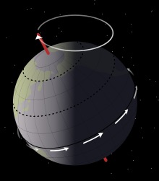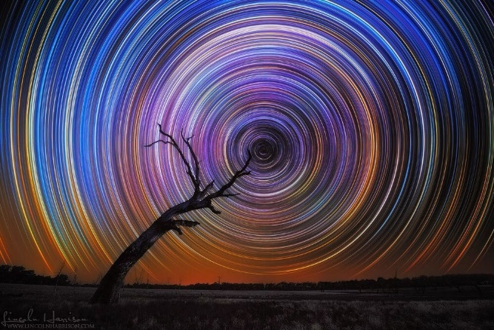
[Left] The axial cone prescribed by precession. [Right] The north pole star, Polaris, remains stationary in time lapse photos while other stars appear to revolve around it due to Earth’s rotation.

Fortnight is a word derived from the Middle English word fourtene night first appeared in the 12th century. As happenstance would have it, perhaps its usage came into use circa 1180 AD when the Earth’s tilt was at its minimal declination. Our world, the plane that our feet stand upon, is skewed 1.34 more degrees than it was back then in the Dark Ages. Those who now gaze upward, stand on a level foundation of understanding solidly built by their forbears who looked up inquisitively at the enchanting orbs glowing bright against the black canvas of the deepest night. That natural awe of the mechanics of the sky above, is, well, no less admirable than the sweetest cat’s meow.

By R. Anthony Saritelli 02/22/2022.
Dedicated to my male, black and white cat, Catapult, who is 10 years old and is surviving his innate but precarious curiosity.

References:
Precession-Wikipedia
Johannes Kepler’s Second Law
Ellipses-Wikipedia
Tropic Of Cancer-Wikipedia
Tropic Of Capricorn-Wikipedia
Earth’s Orbit-Wikipedia
What Are Perihelion & Aphelion? ALMANAC Feb 18, 2022.
Chandler, Hayley: The Tilt of The Planets Blog
Pole Star-Wikipedia
The North Star: Polaris Facts: Science Facts Blog
Solar Insolation-Wikipedia
Astronomical Depictions & Photos from Internet

